

**CST2120**

**Web Applications and Databases**

**Final Report**

Coursework 3

**Restaurant Finder Web Application**

Student Name: Rohini Paligadu

Student ID: M00696984

Module Co-ordinator: Ameerah Assotally

Campus: Mauritius

Table of Contents

1 Introduction 3

2 Features implemented 3

3 Limitations 3

4 Layout of the website 4

5 Database design 8

6 Testing 9

6.1 HTML and CSS Validation 9

6.2 Front end testing using Selenium IDE 10

**Table of figures**

Figure 1 Home section 5

Figure 2 Cuisine section 6

Figure 3 Restaurant section 7

Figure 4 Partner With Us section 8

Figure 5 User Sign Up interface 8

Figure 6 Restaurant owner sign up interface 9

Figure 7 Database Design 9

Figure 8 HTML Validation 10

Figure 9 CSS Validation 10

Figure 10 Successful message after account creation 11

Figure 11 Assert element present 12

Figure 12 Login message 13

Figure 13 Confirm owner account created 14

Figure 14 Assert element present 15

# Introduction

This report describes the implementation of a restaurant finder application, Gourmet Hub. Gourmet Hub is a single-page website that has been designed using HTML, CSS, Javascript, Node.js, Express and MySQL. It allows users to view and sort restaurants found in different locations.

The report consists of six chapters. The first chapter describes the application. The second chapter explains the features implemented while the third one describes the limitations of the website. The fourth chapter consists of screenshots describing the different sections of the website. The fifth chapter describes the database design and finally, the last one demonstrates the tests done.

# Features implemented

The following features have been implemented:

* **Sign up and sign in for users**

A user can register their credentials including their first name, last name, username, email address, password, on the website and login using their existing username and password.

* **Sign up and sign in for restaurant owners**

A restaurant owner can partner with Gourmet Hub by filling in the registration form with their first name, last name, email address, password and phone number. They can log in using their email and password.

* **Display the list of restaurants**

A user can view the entire list of restaurants saved on the database.

* **Sort the list of restaurants alphabetically in ascending or descending order**

A user can sort the list of restaurants in alphabetical order.

* **List restaurants by the type of cuisine**

A user can view restaurants grouped by their cuisine type.

* **Search for restaurant**

A user can enter a location to view the list of restaurants found there.

# Limitations

There are a few limitations associated with the website which I have unfortunately not been able to fix. The search functionality returns an empty array when the user wants to retrieve details of an existing restaurant on the database based on their location. The login feature for both the user and restaurant owner return a “Cannot login” response despite getting the appropriate credentials from the database.

The application could have been further improved by implementing additional features such as allowing the user to add a review on a particular restaurant they visited and allowing the restaurant owner to upload the details of their restaurant.

# Layout of the website

Gourmet Hub comprises of a home section, a cuisine section to view the types of cuisines that restaurants which partnered with Gourmet Hub offer, a restaurant section where the user can view the different types of restaurants, a section to attract restaurant owners who would like to partner up, a sign up section for the user to create their account and login, and finally a similar one for restaurant owners.

The screenshots demonstrate the website layout.

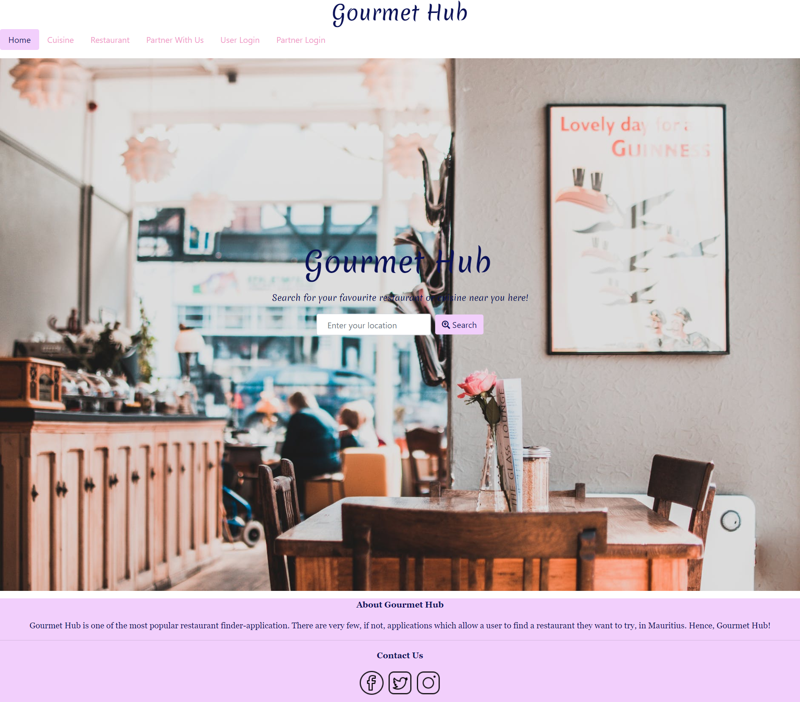

Figure 1 Home section

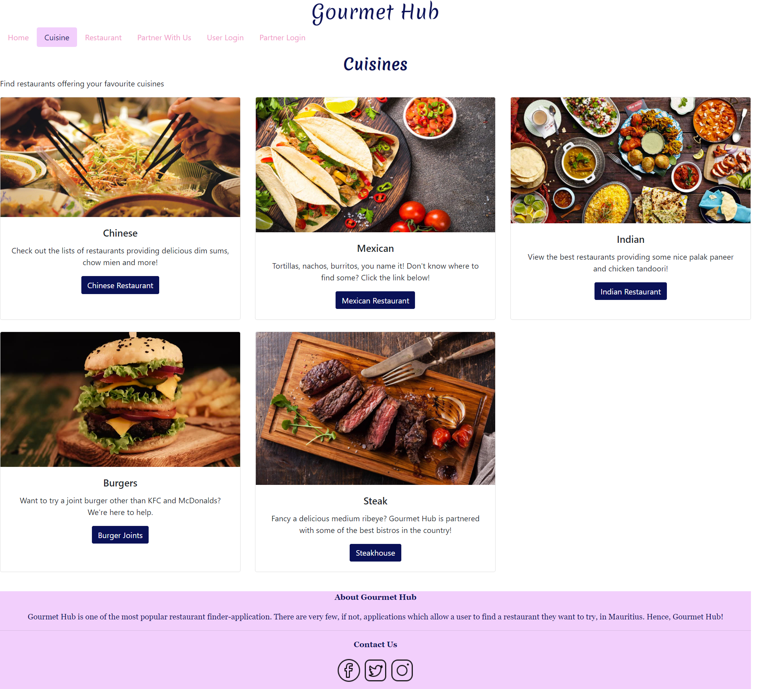

Figure 2 Cuisine section

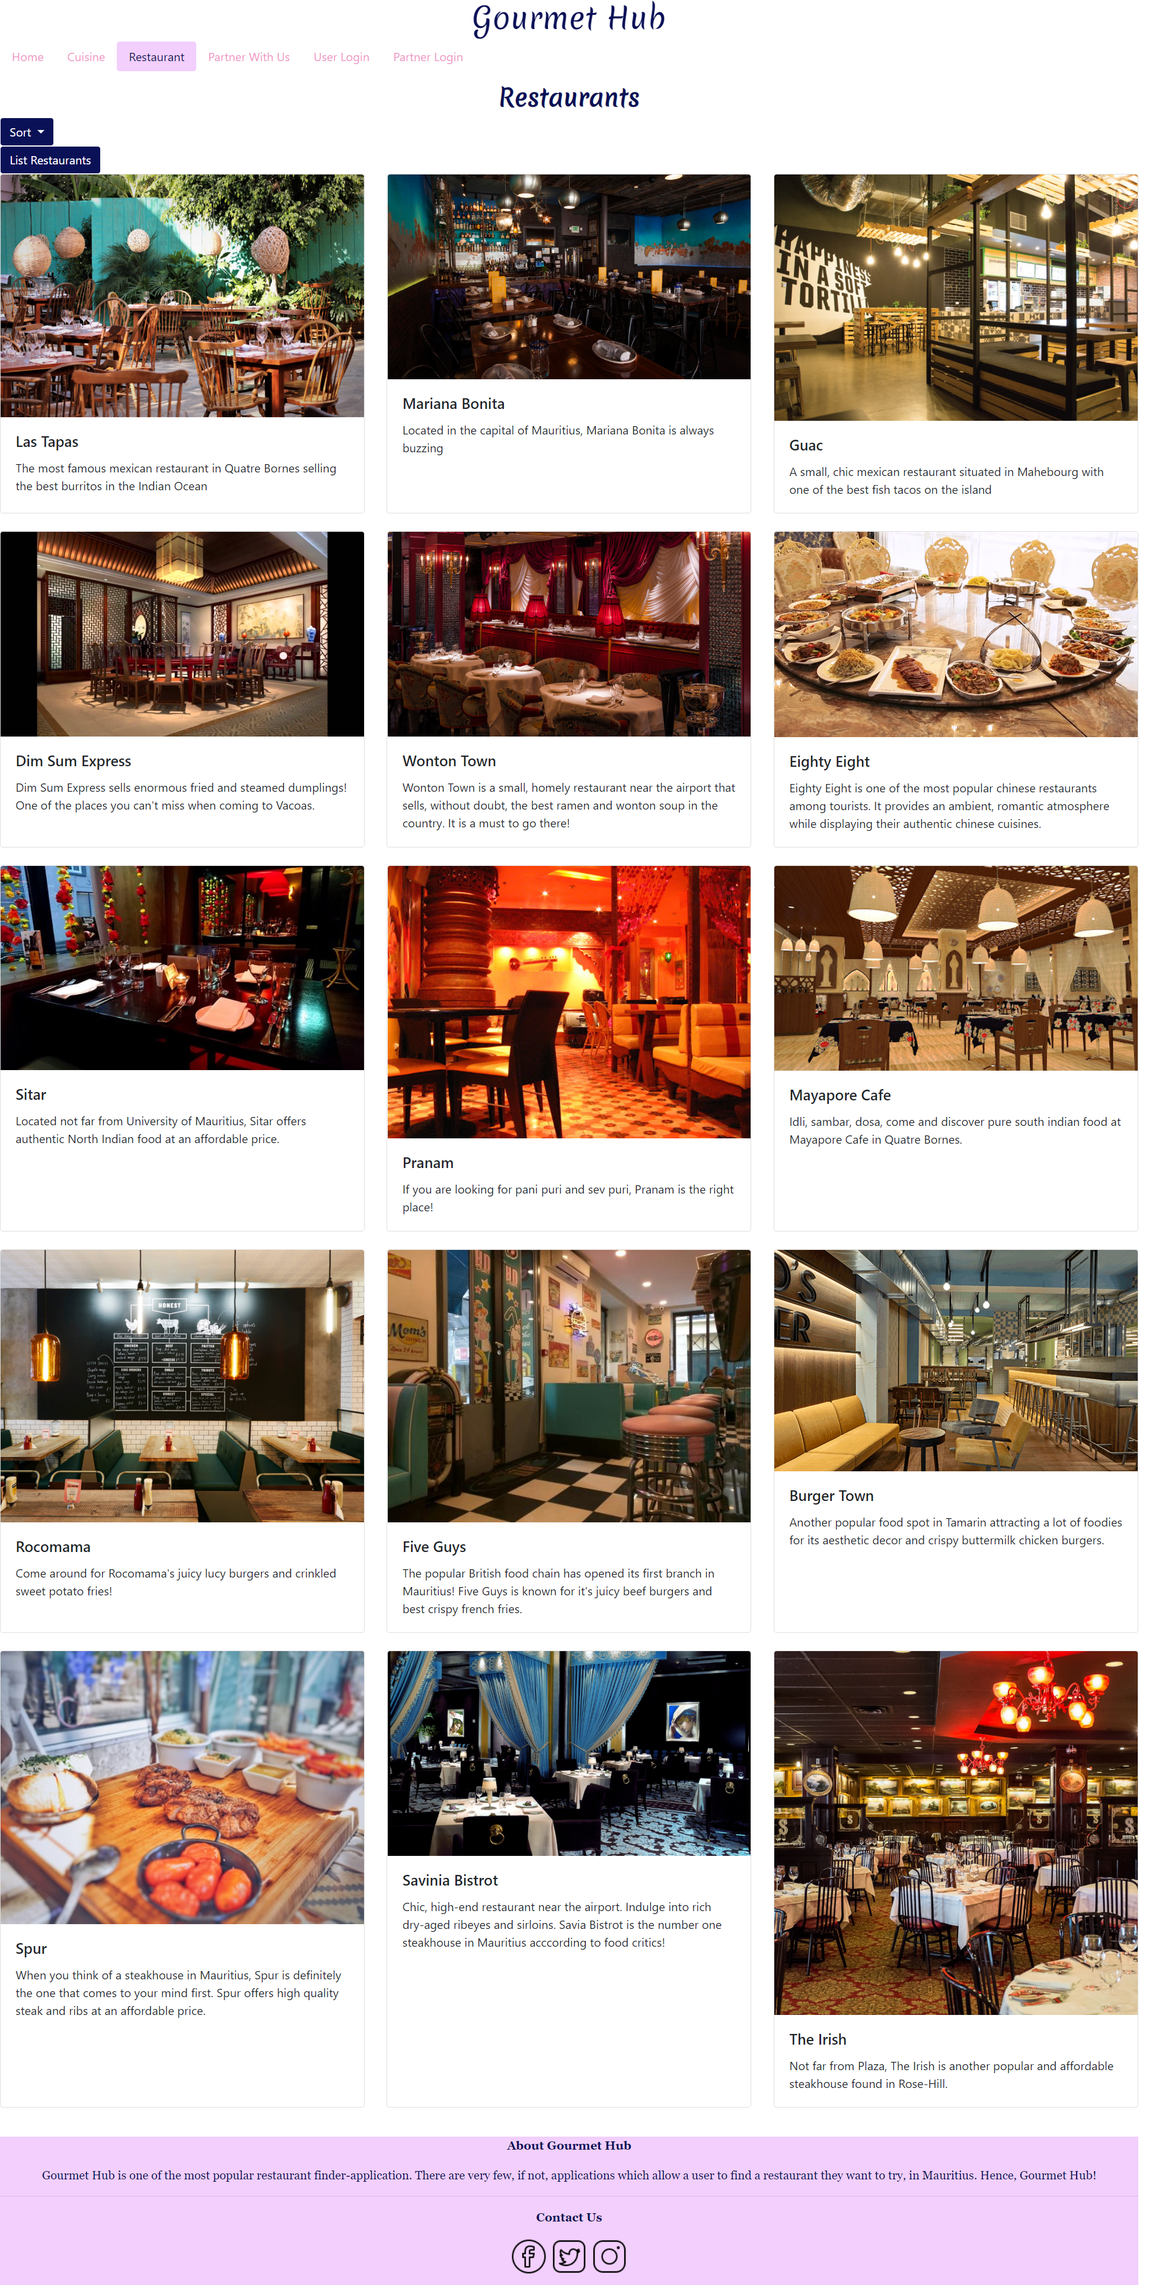

Figure 3 Restaurant section

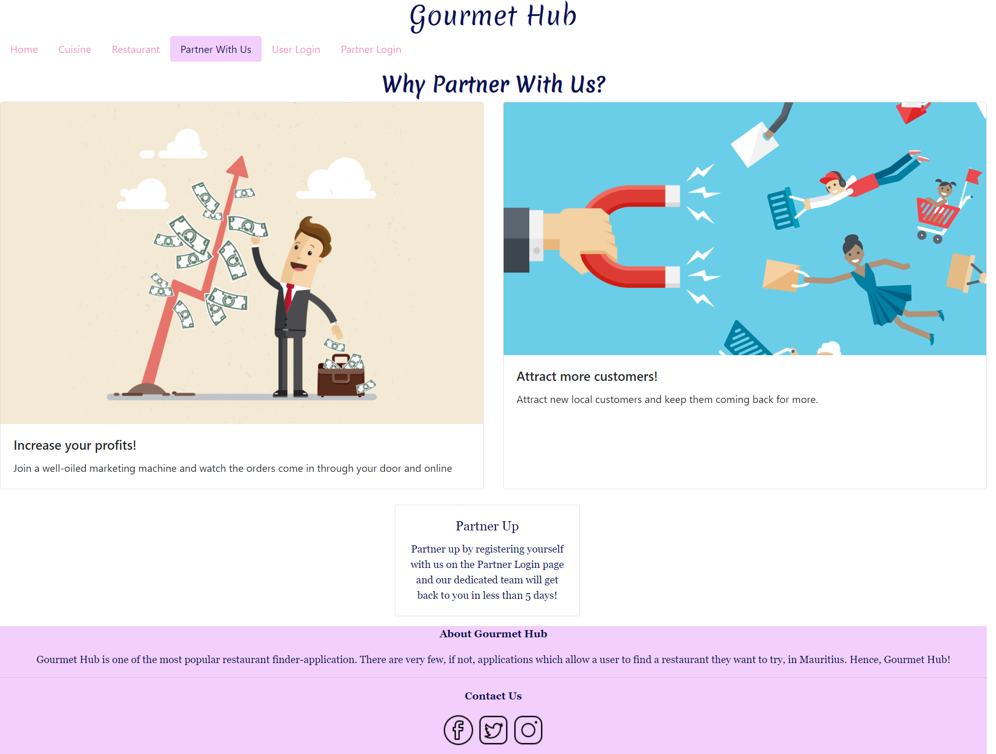

Figure 4 Partner With Us section

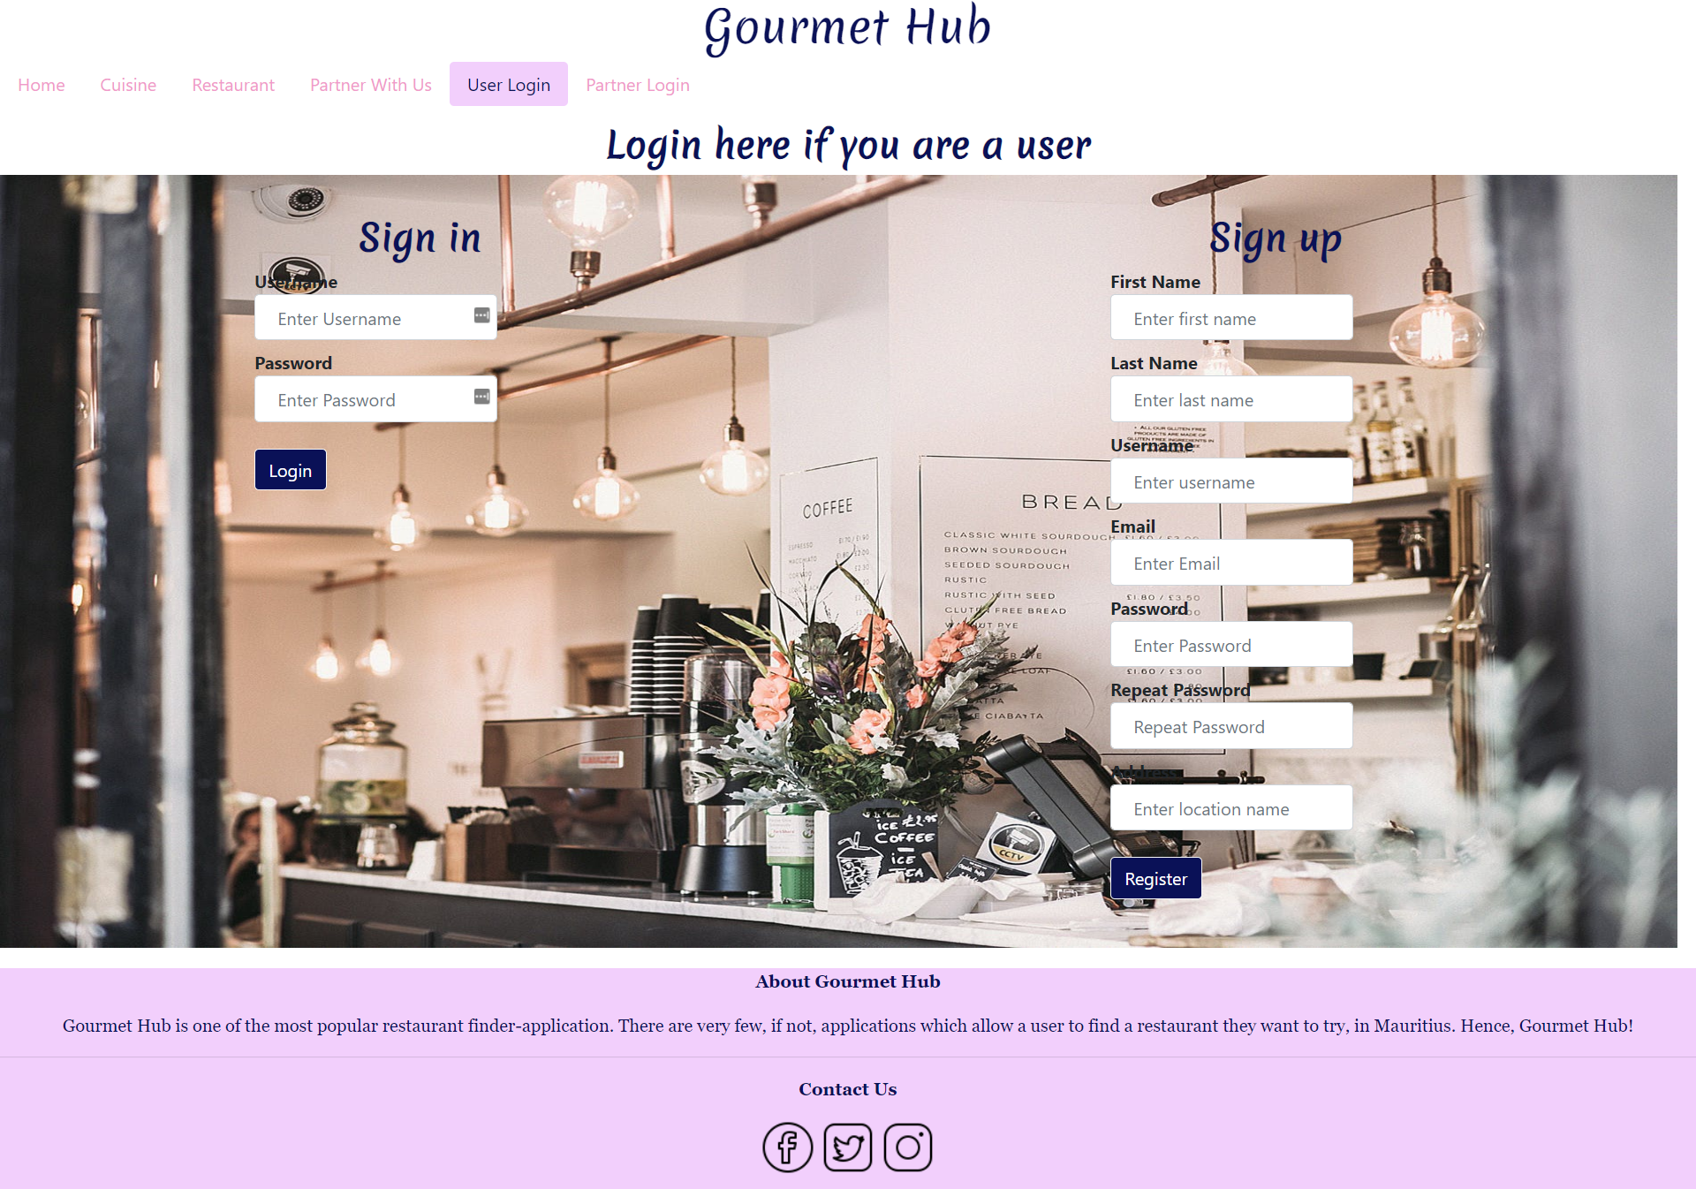

Figure 5 User Sign Up interface

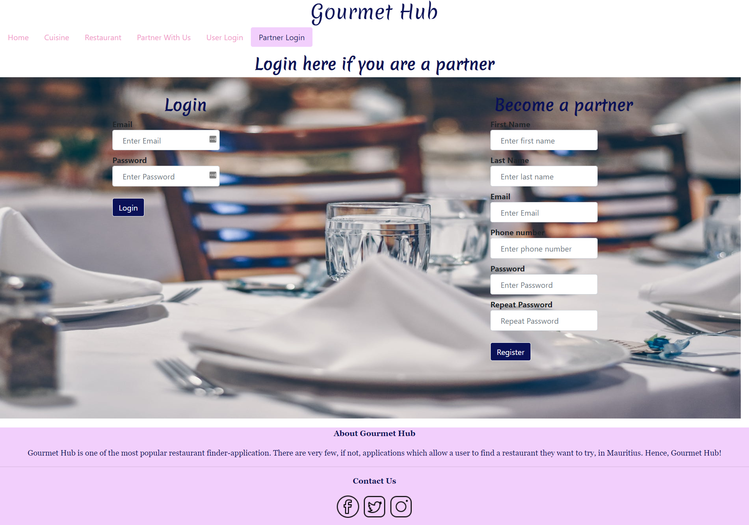

Figure 6 Restaurant owner sign up interface

# Database design

The following assumptions have been made:

* A restaurant owner owns one restaurant.
* A user views one or many restaurants.

Initially, a table recording user reviews was planned to be added but since the “Add review” functionality has not been implemented in the final project, it has been omitted from the database.

The final database design is shown below.



Figure 7 Database Design

# Testing

## HTML and CSS Validation

HTML and CSS have been validated using the W3C Validation services.

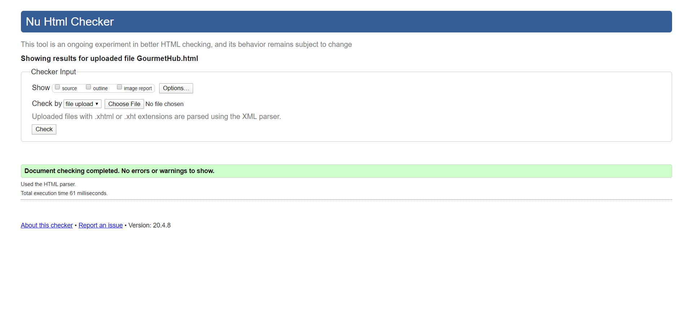

Figure 8 HTML Validation

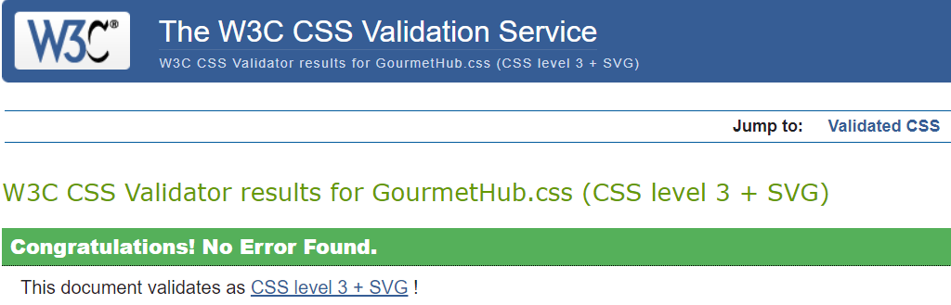

Figure 9 CSS Validation

## Front end testing using Selenium IDE

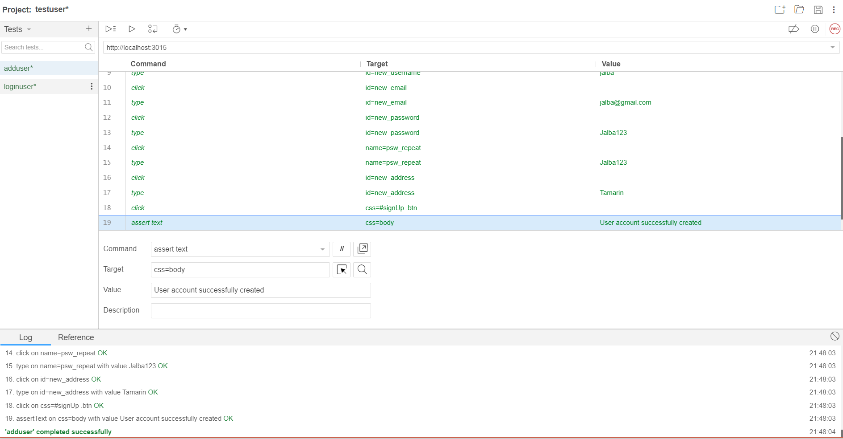

Figure 10 Successful message after account creation

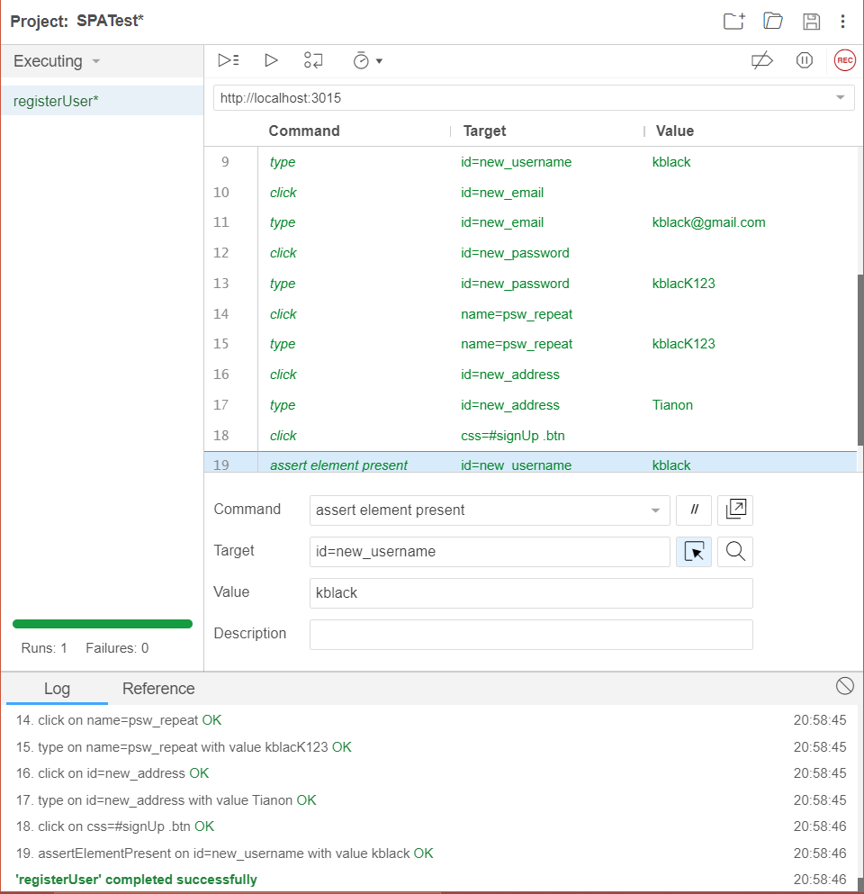

Figure 11 Assert element present

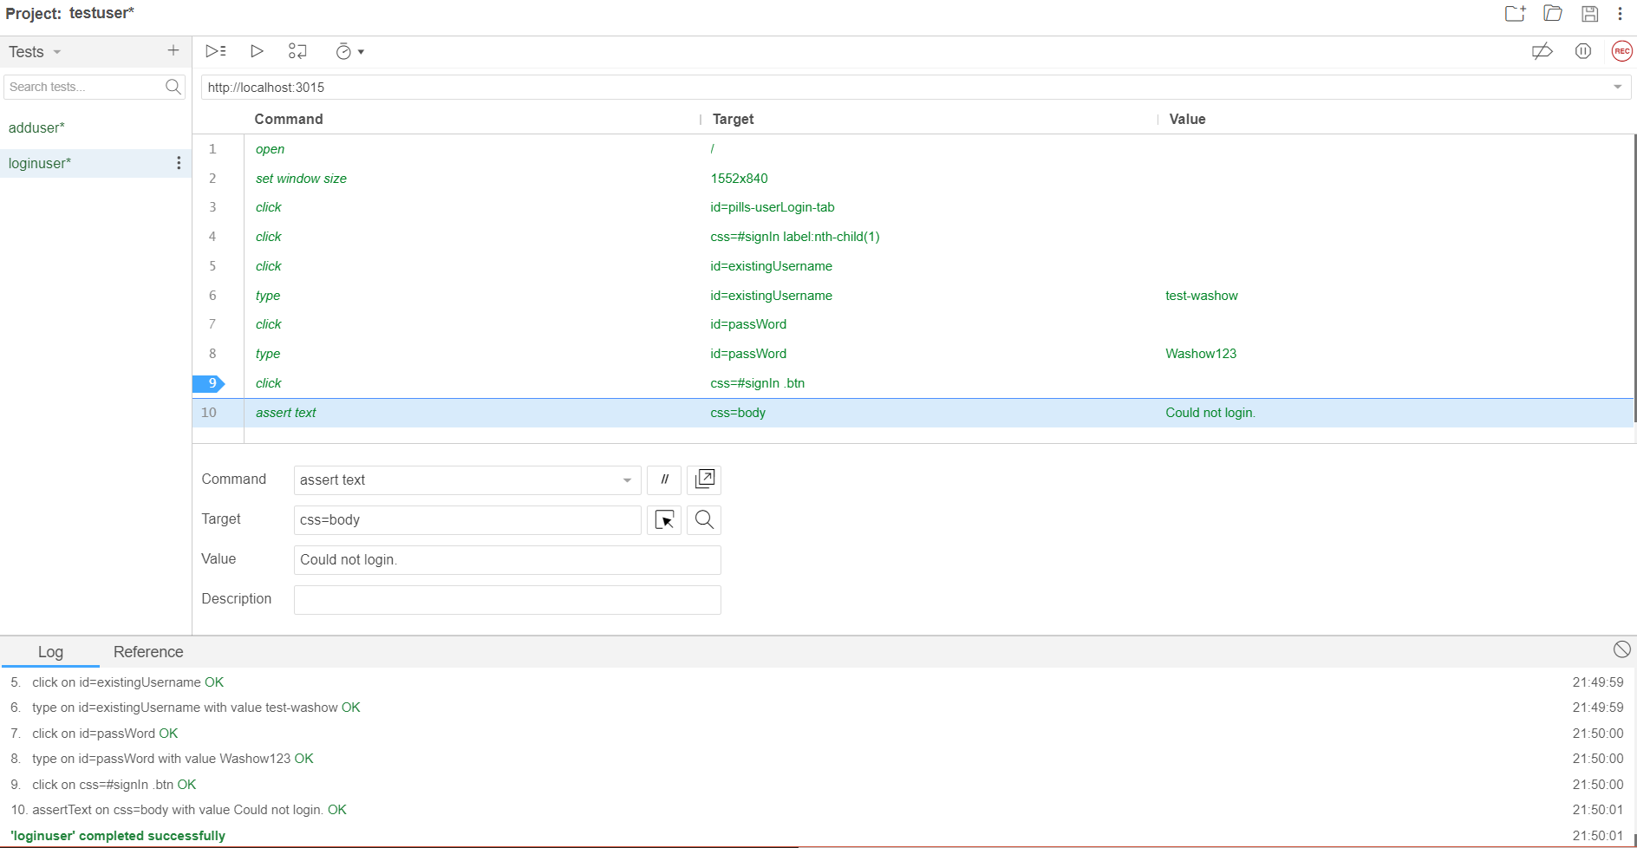

Figure 12 Login message

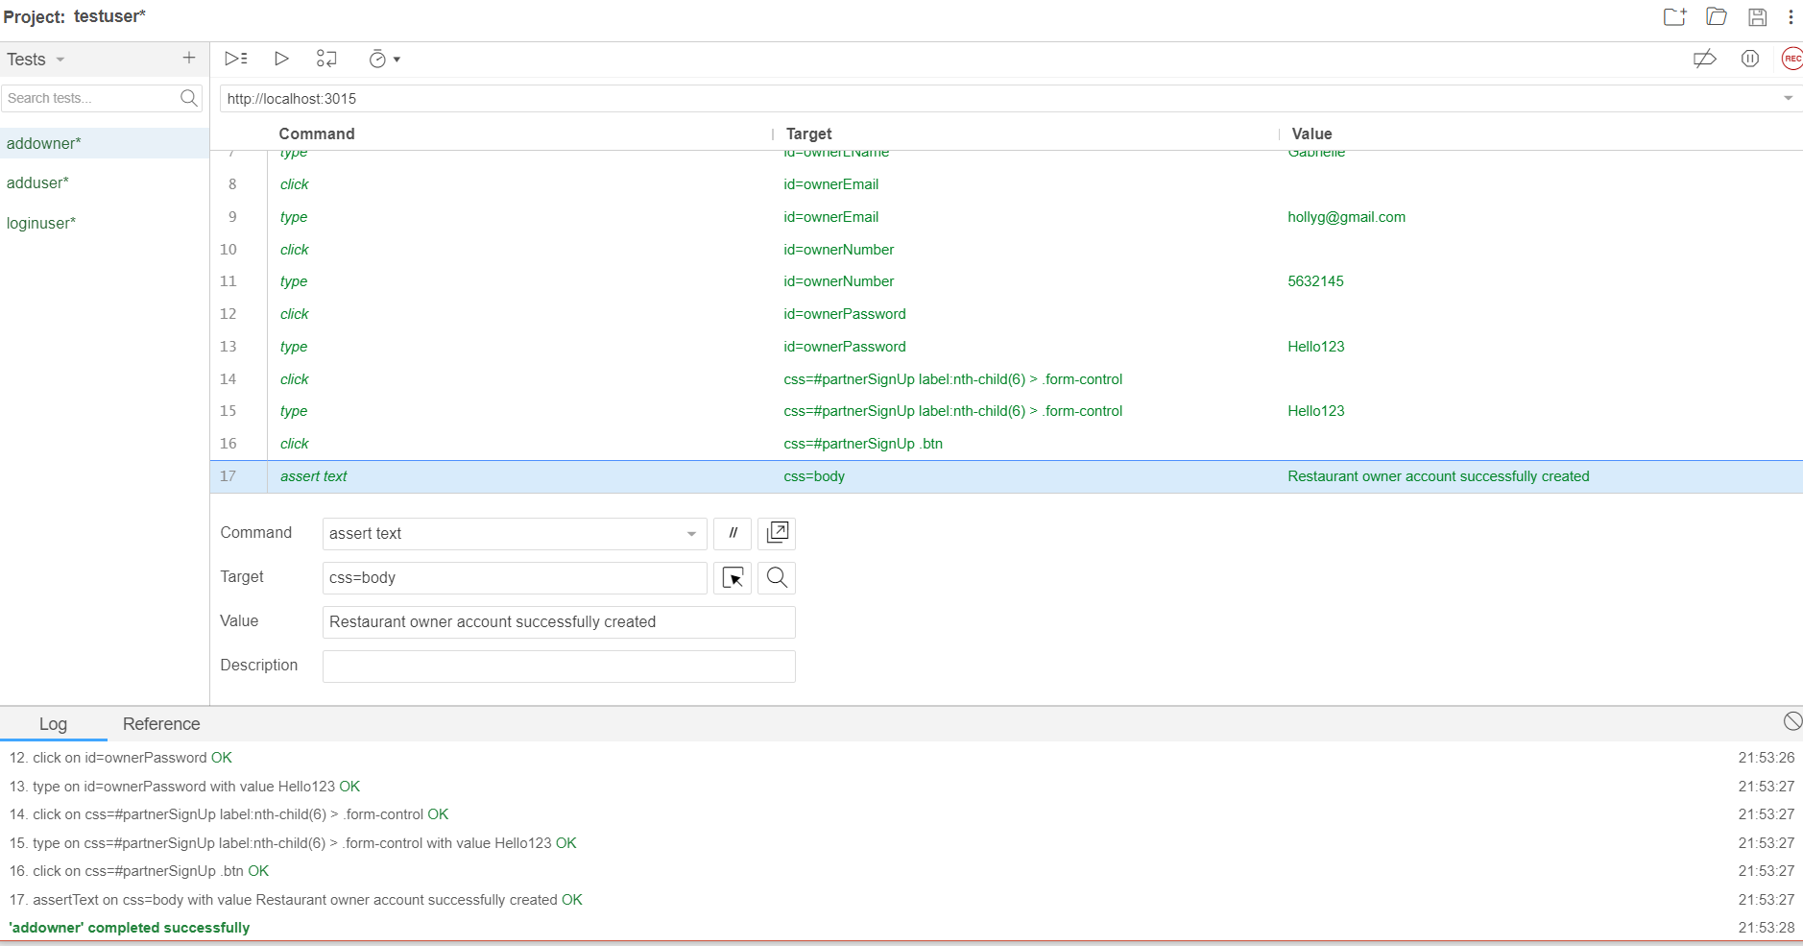

Figure 13 Confirm owner account created

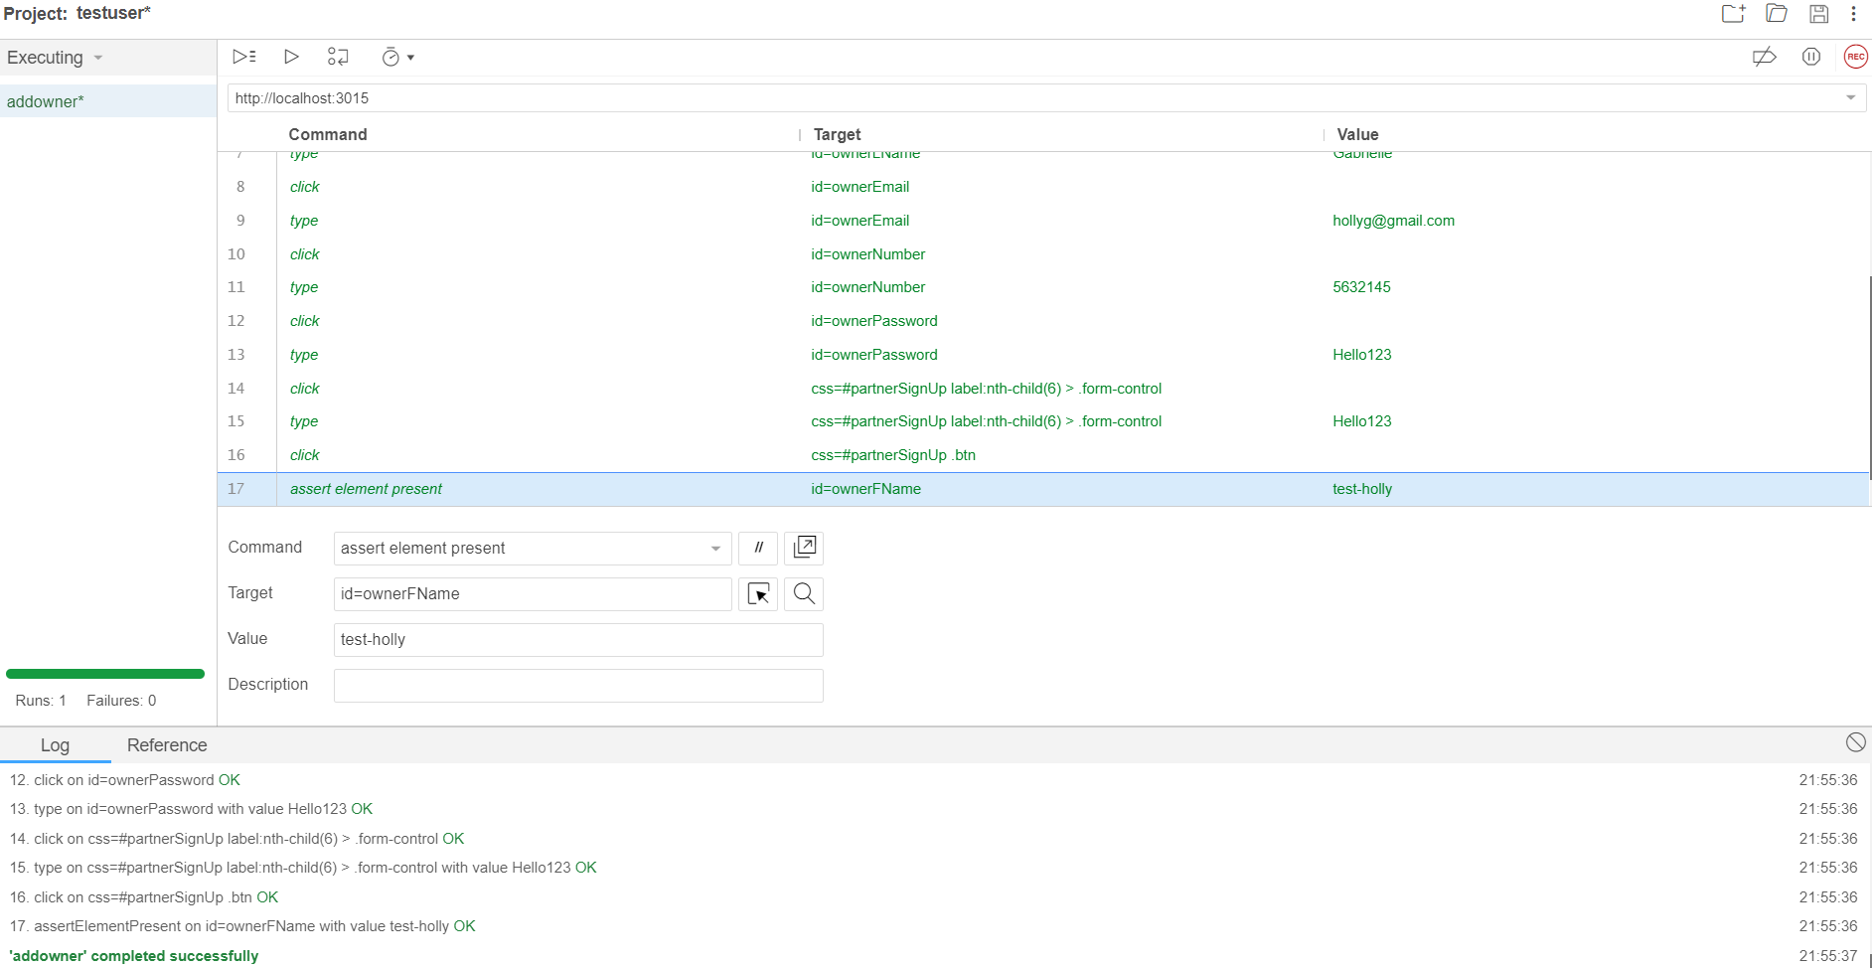

Figure 14 Assert element present